**INGLÉS 5**

**ESTUDIANTE**

**María Alejandra Marín Velásquez**

**CC. 1128481980**

**TEACHER:**

**PABLO ANDRES ARISTIZABAL URIBE**

|  |  |
| --- | --- |
| |  | | --- | |  | |

**Institución Universitaria Esumer**

**Medellín**

**2024**

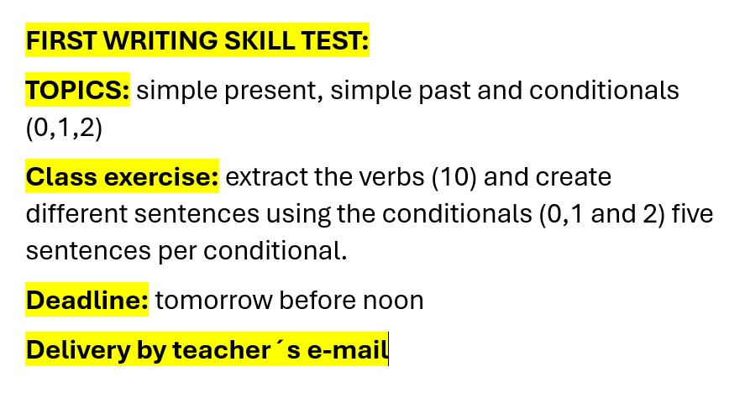

English Activity

1. **These are the ten verbs extracted from the reading**.

Improve

Use

Dry

Developed- develop

Put

Painted

Applied

Wore -wear.

Thought

Being

Designe

Give

Fall out

1. Condicional 0

-If you wear sunscreen, you can protect yourself from the sun.

-If you **put** seeds in The ground, they grow.

-If you **use** a microwave, the food heats up quickly.

-If You leave clothes outside, they **dry**.

-if You **paint** a wall, it changes the color.

1. Conditional 1

-If You practice every Day, You English Will **improve**.

-If you don't **use** sunscreen, you will damage your skin.

-If you Jump, you will **fall out**

-If we get they contact, oye team Will **design** an innovative solution.

-If she practicas every day, she Will **develop** her musical skills.

1. Conditional 2

-If you **used** dangerous hair dye, your hair would have fall out.

-If you did not **improved** your job, you would have lose it.

-If I won the lottery, I would have **painted** My house.

-If I had studied harder, my carrera would have **ended** succesfully.

-If she had Taken my advice, she would have **thought** twice